# MiniProject Report *on*

## **“MOVERS AND PACKERS”**

# Submitted by

#### Kranti Avhad 3164004

#### Shubham Banthia 3164007

#### Pooja Chandak 3164015

Prathamesh Ipkal 3164040

##### Under the Guidance of

### Prof. Anjali A. Shejul Prof. Dr. Pradnya S. Kulkarni

### 

At



DEPARTMENT OF INFORMATION TECHNOLOGY

MIT College of Engineering

## PUNE – 411038

[October 2018]

Affiliated to



SAVITRIBAI PHULE PUNE UNIVERSITY

**CERTIFICATE**

This is to certify that,

Kranti Avhad (3164004)

Shubham Banthia (3164007)

Pooja Chandak (3164015)

Prathamesh Ipkal (3164040)

of class T.E IT have successfully completed their mini project work on “Movers and Packers’’ at MIT College of Engineering in the partial fulfillment of the Graduate Degree course in T.E at the department of **Information Technology**, in the academic Year 2018-2019 Semester – I as prescribed by the Savitribai Phule Pune University.

Prof. Anjali A. Shejul Prof. Dr. Pradnya S. Kulkarni Dr.Krishna K. Wankhede

Guide Head of the Department

(Department of Information Technology)

**Acknowledgements**

We deem it a pleasure to acknowledge our sense of gratitude to our project guides Prof. Anjali A. Shejul and Prof. Pradnya S. Kulkarni under whom we have carried out the project work. Their incisive and objective guidance and timely advice encouraged us to do the entire project with the constant flow.

Kranti Avhad (364004)

Shubham Banthia (3164007)

Pooja Chandak (3164015)

Prathamesh Ipkal (3164040)

**CONTENTS**

|  |  |  |
| --- | --- | --- |
| Sr. No. | Name | Page no. |
| 1. | Introduction | 1 |
| 2. | Scope | 4 |
| 3. | Software/Hardware  Requirement Specifications | 6-11 |
| 4. | Entity Relationship  Diagram | 11-12 |
| 5. | Relational Database  Diagram | 13-17 |
| 6. | Data Normalization | 18-22 |
| 7. | Graphical User Interface | 22-26 |
| 8. | Data Validation | 27 |
| 9. | Conclusions | 28 |
|  |  |  |

**ABSTRACT**

The purpose of Movers & Packers website is to automate the existing manual system by the help of computerized equipment and full-fledged computer software, fulfilling their requirements, so that customer can easily use the transportation services to move different items from one place to another.

Movers & Packers website eases the work by leading to error free, reliable and secure services. It reduces the effort of the users of inquiring different movers & packers services, the charges required, quotation, etc., in person.

The project report describes how the software is going to work, and how it will ease the process of using movers & packers services. It will put some light on the basics of creating the website, and also the steps involved in doing that.

**Chapter 1**  **Introduction**

This project is the design of software which allows easy transportation services of goods from one place to another.Packers and Movers is a company or team that helps you to pack your goods and relocates wherever you want and then unpack those goods. This software is created with an aim to ease the process of using the services provided.

This software reduces the manual effort involved in using the transportation services. Manual effort requires the customer to enquire different movers and packers service providers. Then the customer has to choose the right option among the wide variety available. Customer then has to fill different types of forms for various services provided. While opting for offline services i.e. when the work is done manually, errors are bound to happen. This product is designed to avoid such types of errors and to make the work relatively easy. Error messages are displayed if invalid data is entered. The user does not need any technical knowledge to use the website. It is user friendly.

The details entered by the customer is added in the database in back-end. The database is handled by the system administrator. The CRUD operations, insert, modify, update and delete are carried out by the system administrator. In this project, the back-end contains information like order-id, name, contact, email-id, the place from where goods are to be transported and destination, etc. Customer has to enter these details in the front-end which are stored in database. System administrator can view, update, add and delete the data from database.

System administrator can view customer details, shipping details and feedback given by all customers. Based on these details, system administrator can make changes in the website if required. Different types of forms like registration, login, quote form and feedback are provided for users to fill in their details. These details are stored in database which is visible to system administrator.

If the customer is not registered with our website, he/she has to fill the registration form. Once the registration form is submitted, customer can login with the credentials. To place the order user must fill quote form. Quote form consists fields named customer’s name, contact number, number of items to be transported and cities from and to where the goods are taken

In this document, the entity relationship diagram, relational database design and data normalization have been shown. The aim is to provide a better understanding of the website, its working, and the implementation.

An entity relationship diagram (ERD) shows the relationships of entity sets stored in a database. An entity in this context is an object, a component of data. An entity set is a collection of similar entities. These entities can have attributes that define its properties. By defining the entities, their attributes, and showing the relationships between them, an ER diagram illustrates the logical structure of databases. ER diagrams are used to sketch out the design of a database.

**Chapter 2**  **Scope**

The product to be produced is intended for the safe and quick delivery of various goods among various cities. This process will be carried out by the website.

* The end-user is the customer, who intends to ship their goods. The user will have to choose the items and cities. The user can navigate through the details of various options, and then further, the user can make the choices.
* The MAIN goal is to facilitate easy booking and shipping of the goods, for any customer who accesses the website. This will prove to be very useful because the number of facilities is huge, and the automation of the process of confirming and billing can help the customer to find the best options to deliver in minimum time.
* This project is cost efficient. It reduces the cost of overall process.

**Chapter 3**  **Software/Hardware Requirements** **Specification**

The Pune Movers and Packers Website, is a website for transportation services over various destinations, through means of an online website. The following subsections provide an overview.

**3.1 PURPOSE OF DOCUMENT**

* It gives a comprehensive view of how the system is supposed to work, and also what is to be expected by the end users.
* It provides a better understanding of the project, which will be useful for development and also future stages. It provides a blueprint of the project, which may be useful for modifications and maintenance.

**3.2 DEFINITIONS, ACRONYMS AND ABBREVIATIONS**

* S.R.S. 🡺Software Requirement Specifications
* A.P.I. 🡺Applications Interface
* S.S. 🡺Shipping System
* Blueprint 🡺A technical plan of the project
* End Users 🡺The people who will be actually using the system
* C.M.S. tool 🡺Content Management System tool

**3.3 Overall Description**

**3.3.1 Product Perspective**

Shipping System is a self-contained software product, which is developed while keeping in mind the problems that customers face due to the current system.

The newly produced system will provide the customer an easy access to the data of various goods to deliver. The user-friendly nature will make the functioning of this system hassle-free.

**3.3.2 Product Functions**

General functions of the product are as follows

1. Customer Registration.
2. Customer Log in.
3. Providing the list of available goods under our scope of business.
4. Navigating through the list and options of available items.
5. Navigating through the list of cities where the services are available.
6. Displaying the details and price of a particular good.
7. Displaying the goods available, and their prices for shipping.
8. Placing order and confirmation system, where the user can order one/many goods for shipping at desired destination.
9. Maintaining an account for registered users, displaying their data and the actions performed on the website by them.
10. Customer can also give feedback.

**3.3.3 User Characteristics**

* User can view (only) the entries.
* Customer can place their order for shipping.
* Customer must have basic knowledge of a computer system, and also about the general working of a website.

**3.3.4 Constraints, Assumptions and Dependencies**

1. User must have been registered and logged in to access the website.

The website is in English language, user must be well-versed with it.

1. It is assumed that the user has a reliable internet connection.

**3.4 Specific Requirements**

**3.4.1 External Interface Requirements**

1. **User interface:**

User interface, i.e. the website itself, will be compatible to any type of browser such as Mozilla Firefox, Google Chrome, and Internet Explorer.

1. **Software interface:**

* Web Server-
* Apache Tomcat Server
* O.S. (Windows, Linux, etc.)
* Development End-
* C.S.S. (Cascading Style Sheets)
* Java-script
* P.H.P.

**3.4.2 Functional Requirements**

1. 🡺Customer should be able to register with their details
2. 🡺System should accept and validate the following details

🡪Name

🡪Email-id 🡪Password

1. 🡺Customer should be able to log in successfully after registration.
2. 🡺Customer should be able to place an order.
3. 🡺Customer should be able to confirm their order.
4. 🡺Customer should be able to provide feedback.

**3.4.3 Non-functional requirements**

NF 1🡺Loading of pages and form submission should not take too long.

NF 2🡺Redirection between pages should be smooth.

NF 3🡺User’s password should be a hidden one, and should be validated properly.

NF 4🡺 Under failures, error messages should be properly displayed.

NF 5🡺Validations must be proper to ensure that invalid data is not accepted, and the data is in a proper format.

NF 6🡺 The website should work regularly under any circumstances, in normal conditions.

**3.5 Procedure**

**3.5.1 Steps in creation of website:**

* The nature of the website is discussed, i.e. the number of pages, interfaces, forms, etc.
* The work of development of pages is divided.
* In page creation, first the layout of the page is decided.
* For forms, necessary fields are added and their layout is decided.
* Validations are done wherever necessary.
* Linking of pages is done.
* Visually appealing features are added as per requirement.
* On completion, the website is tested for various cases.

**3.5.2 Flow of the website:**

* User goes to the website, via URL.
* The user is on the login page now.
* If the user is registered, he/she can log in and proceed.
* If the user is unregistered, he/she can click on the register button and will be redirected to the registration page, where the user will have to enter some details and register.
* On logging in, the user is redirected to the HOME page.
* Here, the user can place their order, by entering the required details, like cities, moving date, moving time, etc.
* Once this is done, the user will be taken to confirming page, where the user can enter/confirm details and place the order.
* The confirmation part is complete here. As an option, the customer can also provide a feedback by clicking on the feedback button.

**3.5.3 Software Requirements**

* Operating system: Windows, Linux, MacOS.
* Web Browser: Google Chrome, Internet Explorer (ver. 8+), Microsoft Edge, Mozilla Firefox.
* Text editor: Notepad, Notepad++, Sublime, etc.

**3.5.4 Hardware Requirements**

* R.A.M.

Minimum 1GB or higher.

* Processor

Intel, or AMD.

* Internet Connection

L.A.N., Broadband, Wifi, etc.

**Chapter 4 Entity Relationship Diagram**

**____________________________________________________________**

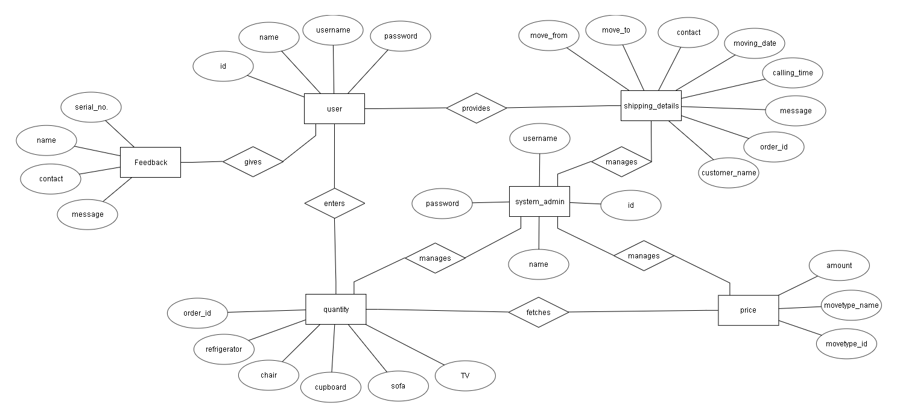

**Chapter 5 Relational Database Design**

**____________________________________________________________**

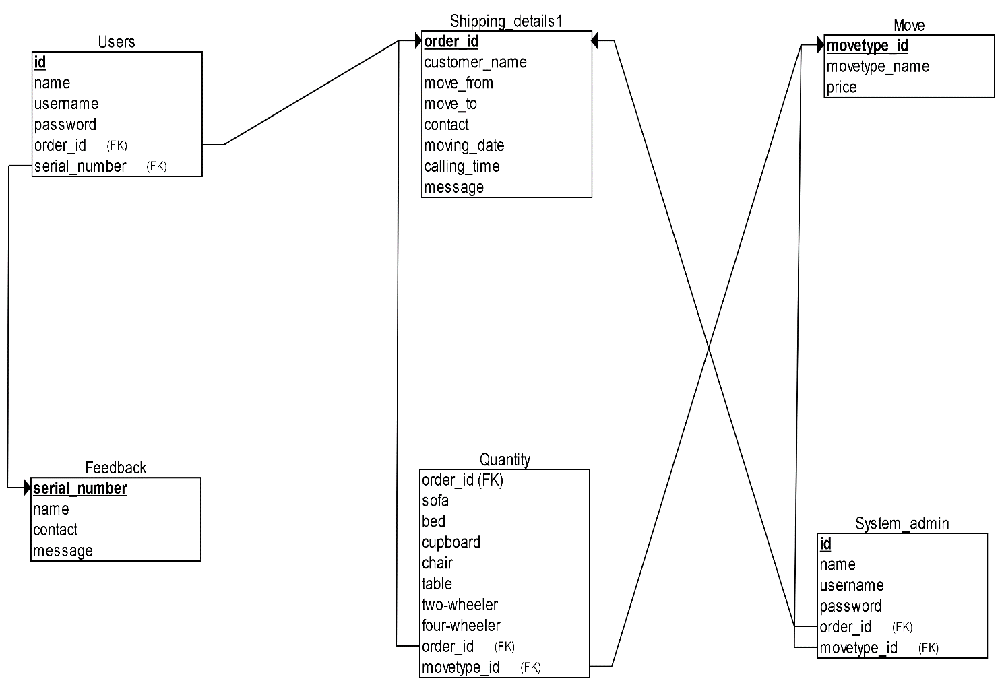

**Chapter 6 Data Normalization**

**___________________________________________________________**

**Normalization –**

It is the process of minimizing **redundancy** from a relation or set of relations. Redundancy in relation may cause insertion, deletion and updation anomalies. So, it helps to minimize the redundancy in relations. **Normal forms** are used to eliminate or reduce redundancy in database tables.

### 1.    First Normal Form – If a relation contain composite or multi-valued attribute, it violates first normal form or a relation is in first normal form if it does not contain any composite or m­­­ulti-valued attribute. A relation is in first normal form if every attribute in that relation is singled valued attribute.

▪  **Example 1 –** Relation STUDENT in table 1 is not in 1NF because of multi-valued attribute STUD_PHONE. Its decomposition into 1NF has been shown in table 2.  
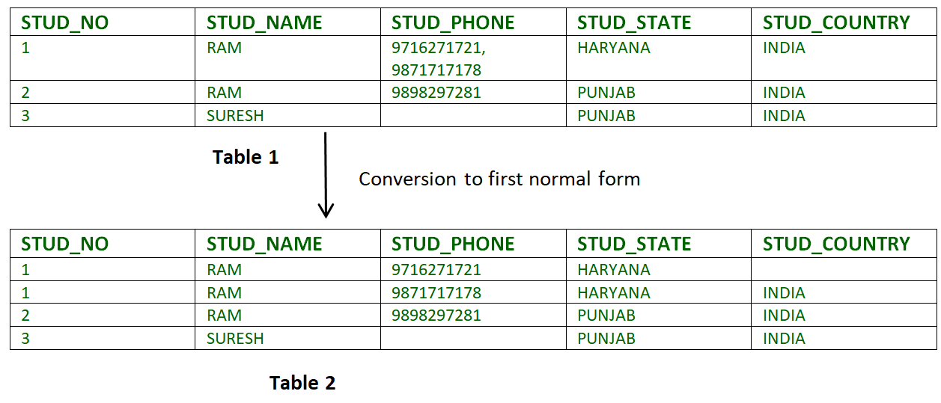

### 2.  Second Normal Form –To be in second normal form, a relation must be in first normal form and relation must not contain any partial dependency. A relation is in 2NF iff it has ****No Partial Dependency,****i.e.****,****no non-prime attribute (attributes which are not part of any candidate key) is dependent on any proper subset of any candidate key of the table.

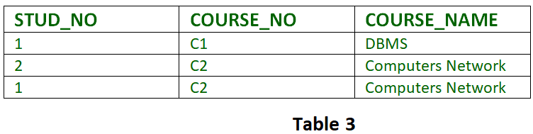

**Partial Dependency –** If proper subset of candidate key determines non-prime attribute, it is called partial dependency.

**3. Third Normal Form –** A relation is in third normal form, if there is no transitive dependency for non-prime attributes is it is in second normal form.  
A relation is in 3NF iff **at least one of the following condition holds** in every non-trivial function dependency X –> Y

1.    X is a super key.

2.    Y is a prime attribute (each element of Y is part of some candidate key).

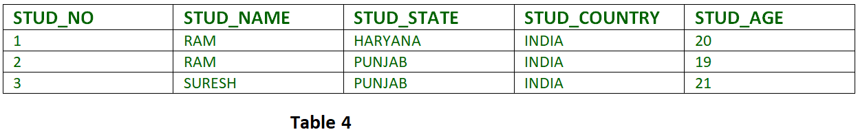 **Transitive dependency –**If A->B and B->C are two FDs then A->C is called transitive xsddependency.

**NORMALIZATION USED IN TABLES –**

**Admin-**

|  |  |  |  |
| --- | --- | --- | --- |
| Id | Name | Username | Password |

**System Admin-**

|  |  |  |  |
| --- | --- | --- | --- |
| Id | Name | Username | Password |

**Shipping Details-**

|  |  |
| --- | --- |
| Order id |  |
| Customer name |  |
| Contact number |  |
| Move from |  |
| Move to |  |
| Date of moving |  |
| Time |  |
| Movetype id |  |
| Movetype |  |
| Price |  |
| Message |  |
| Sofa |  |
| Bed |  |
| Cupboard |  |
| T.V |  |
| Refrigerator |  |
| Two wheeler |  |
| Four wheeler |  |
| Table |  |
| Chair |  |

**Feedback-**

|  |  |  |  |
| --- | --- | --- | --- |
| Sr.no. | Name | Contact number | Message |

* As we have not used any multi valued attributes in our tables, the tables are in First Normal Form.
* There is no composite key in any of the tables. A single primary key is present all the attributes being dependent on the primary key itself making the tables in Second Normal Form.

 The shipping details table is not in third normal form. Therefore we split it into three tables.

BUT AS THERE IS TRANSITIVE DEPENDENCY ( price dependent upon movetype _id and movetype _id dependent upon order_id)  IN THE move. It is not in third normal form.

**Shipping Details-**

|  |  |
| --- | --- |
| Order id |  |
| Customer name |  |
| Move from |  |
| Move to |  |
| Contact number |  |
| Date |  |
| Time |  |
| Message |  |

**Quantity-**

|  |  |  |  |  |  |  |  |  |  |
| --- | --- | --- | --- | --- | --- | --- | --- | --- | --- |
| Order id | Sofa | Bed | Cupboard | T.V | Refrigerator | Two wheeler | Four wheeler | Table | Chair |

**Move-**

|  |  |  |
| --- | --- | --- |
| Movetype id | Movetype | Price |

Now all the tables are in third normal form. Normalization reduces data redundancy and data loss, hence a project should at least be in third normal form to ensure quality of software.

**Chapter 7 Graphical User Interface**

**____________________________________________________________**

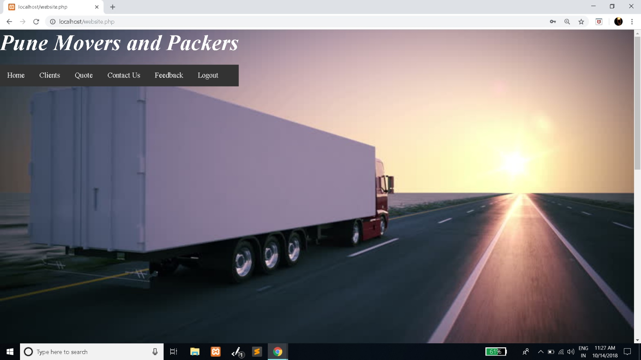

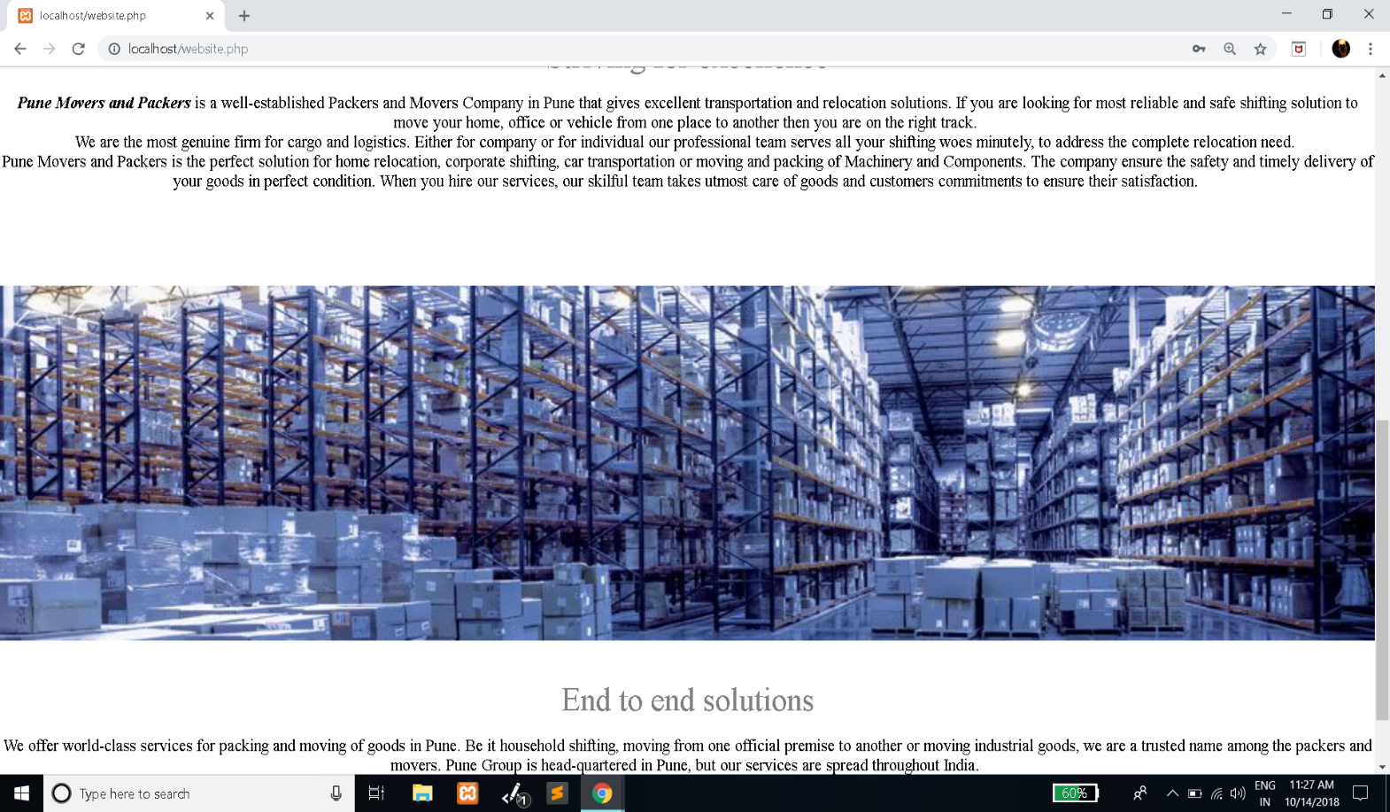

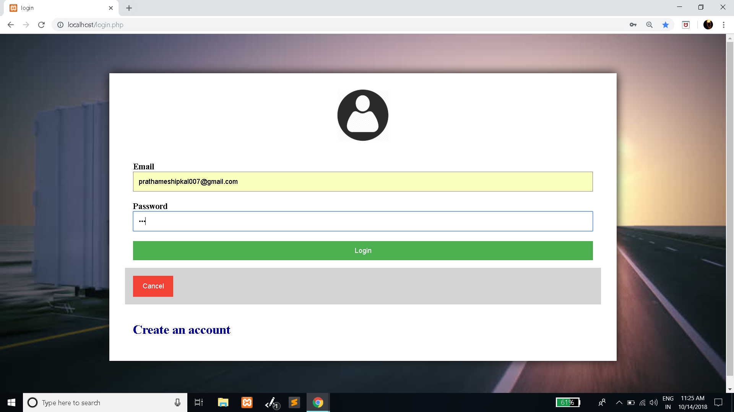

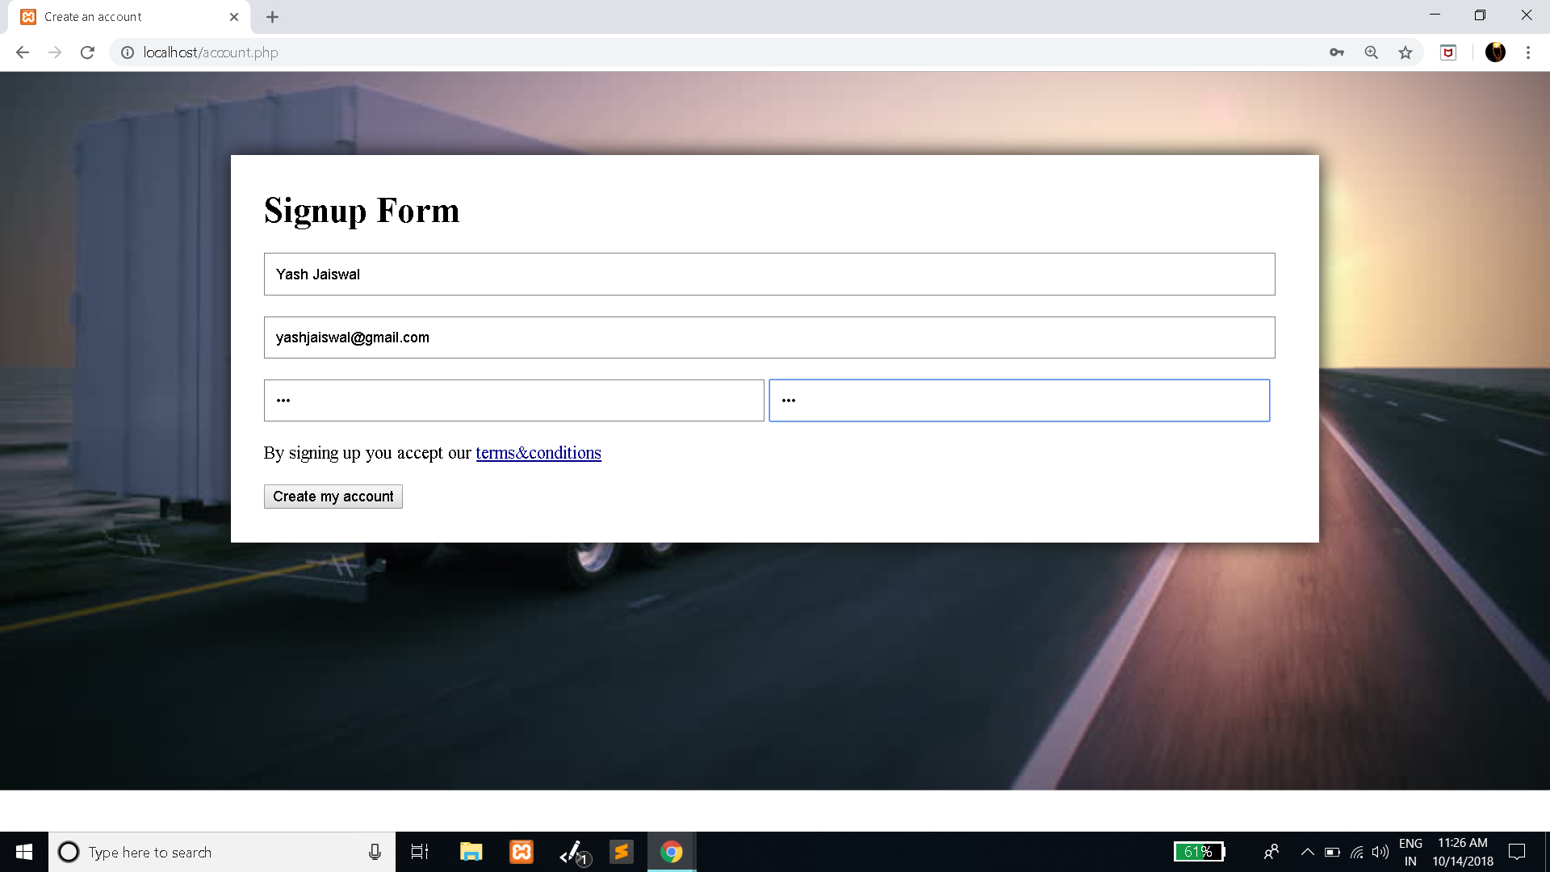



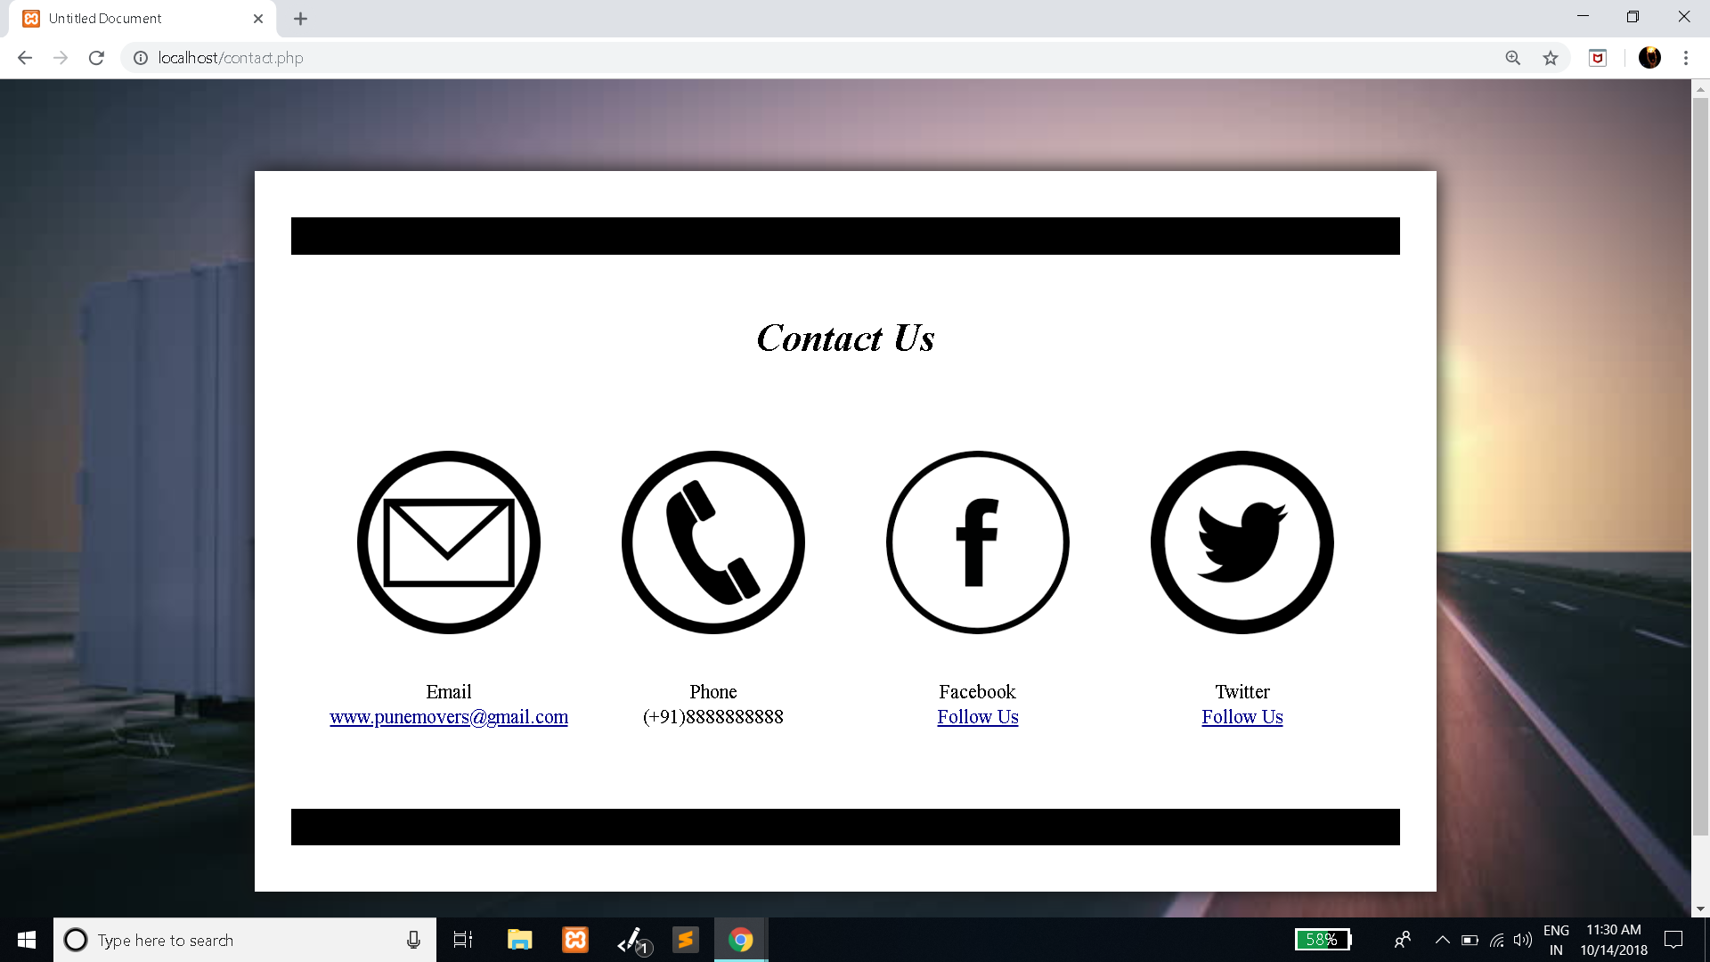

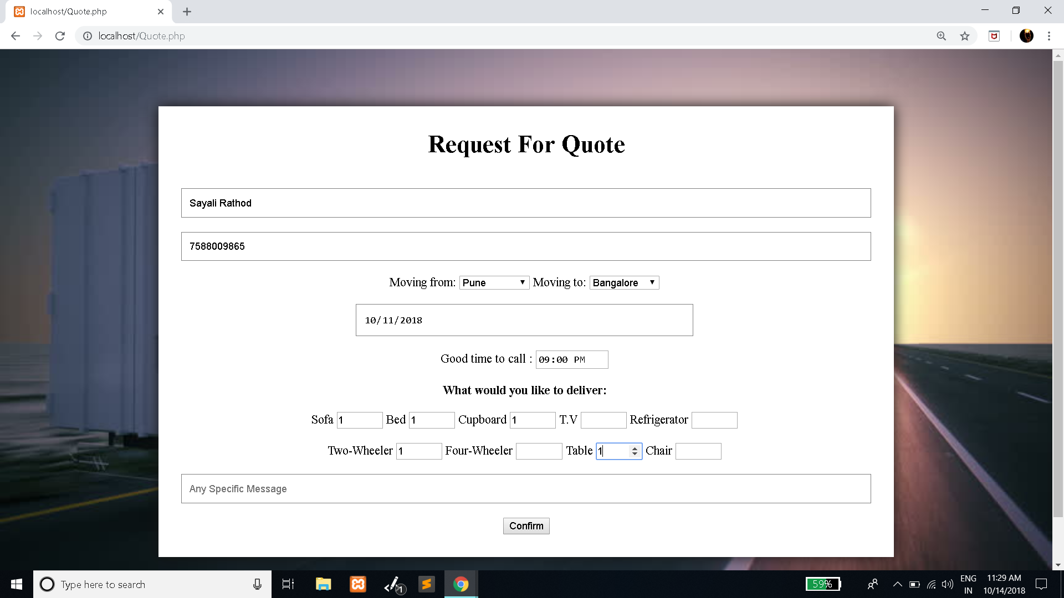

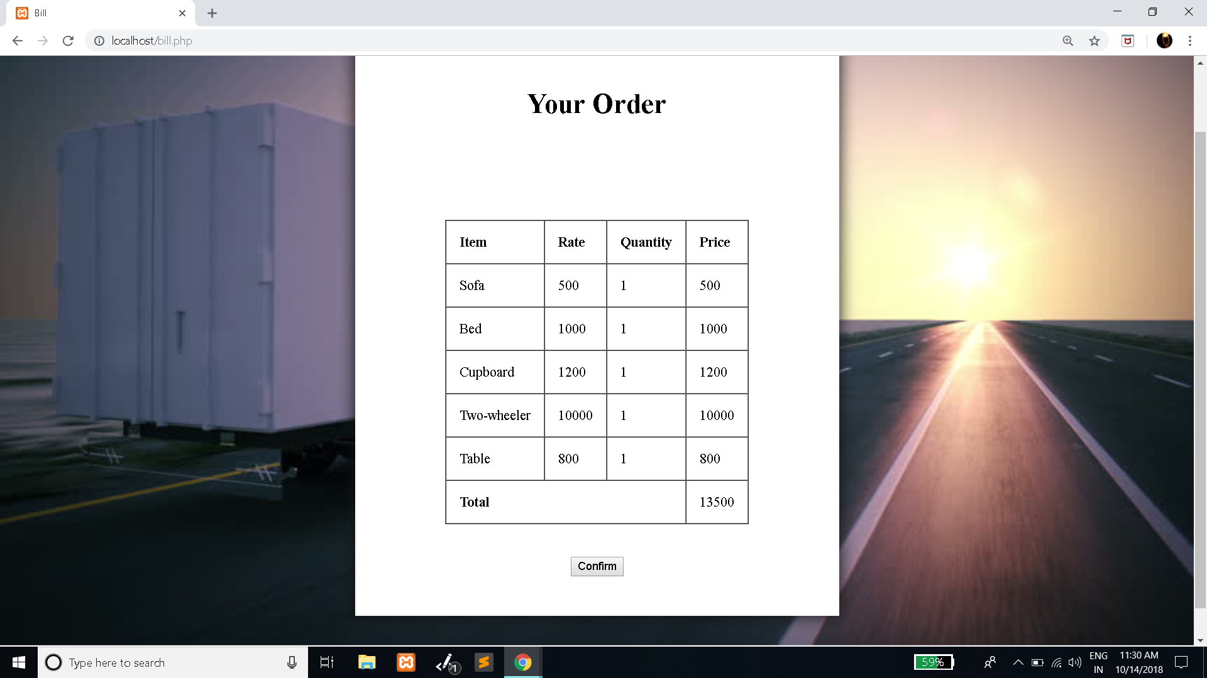

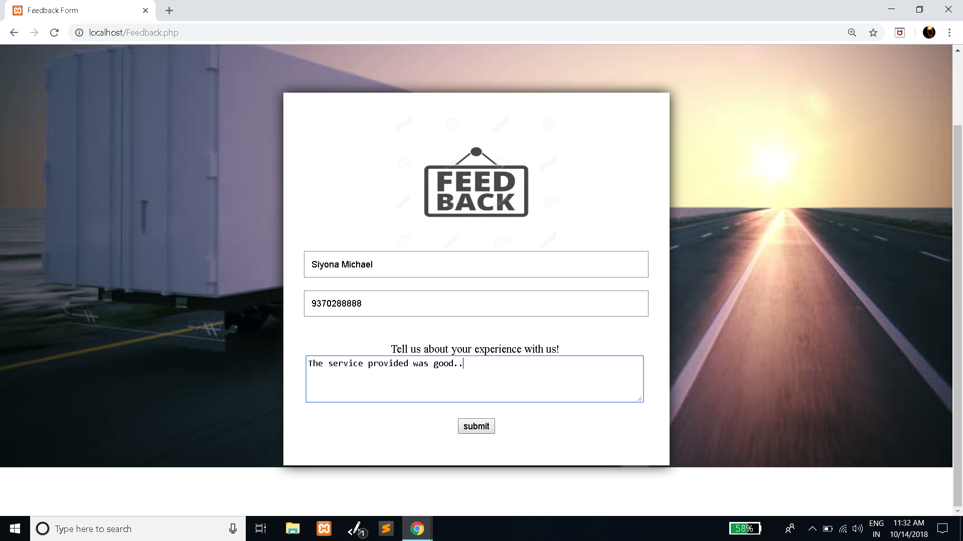

**Chapter 9 Testing : Data Validation**

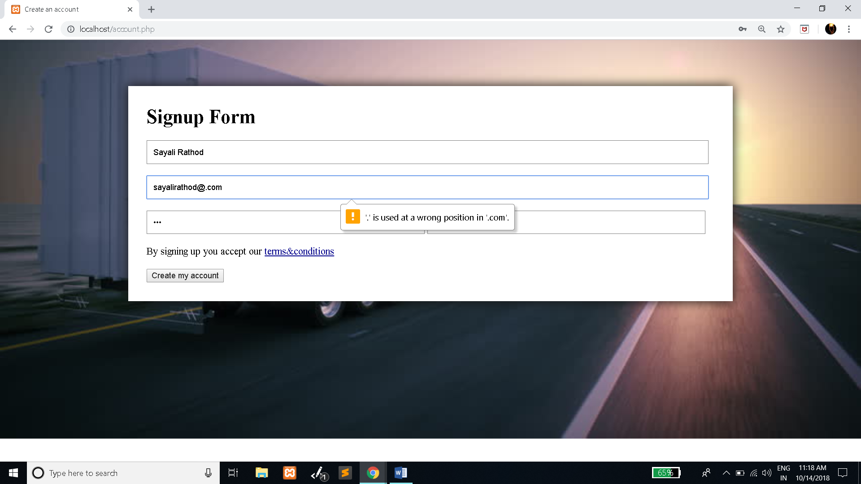

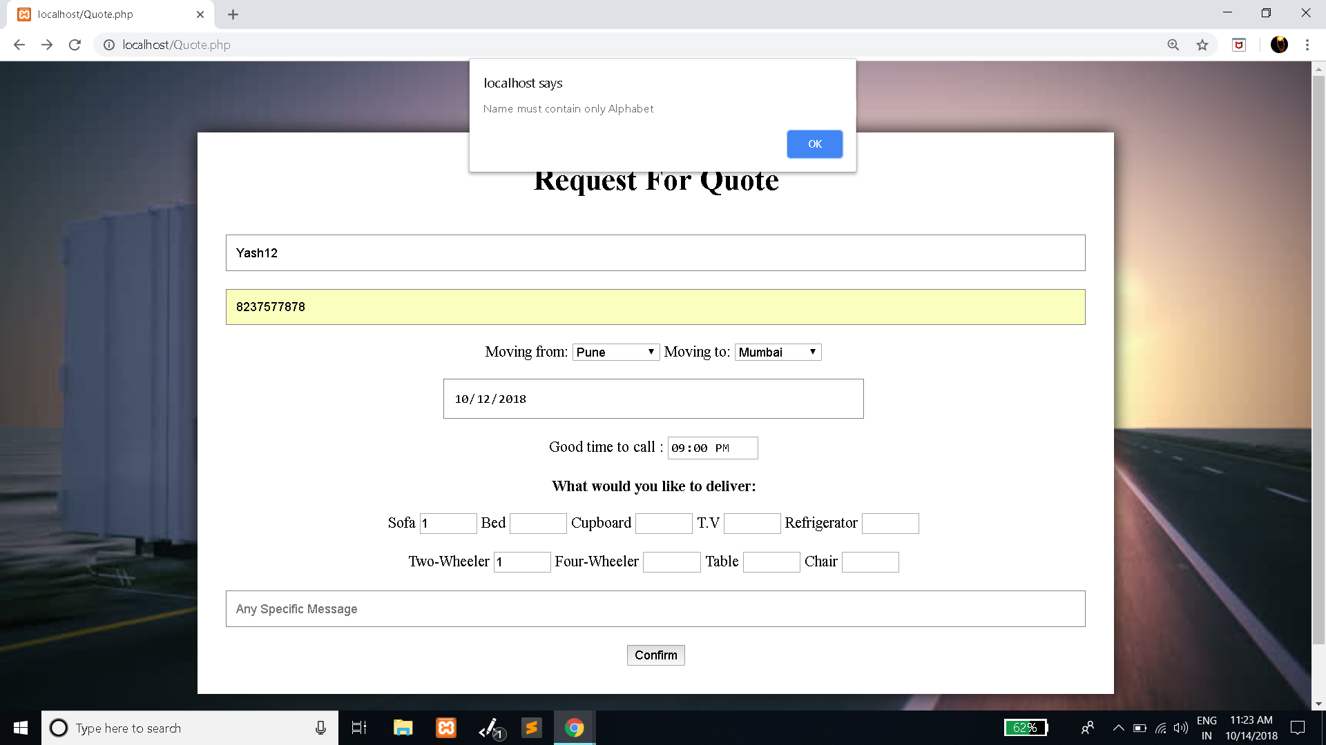

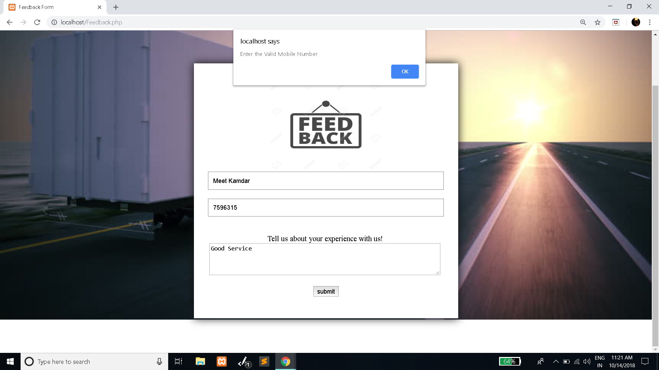

**Chapter 10 Conclusion**

**____________________________________________________________**

Our project is only a humble venture to satisfy the needs to manage their project work. Several user friendly coding have also adopted. This package shall prove to be a powerful package in satisfying all the requirements of the school. The objective of software planning is to provide a frame work that enables the manger to make reasonable estimates made within a limited time frame at the beginning of the software project and should be updated regularly as the project progresses.

**At the end it is concluded that we have made effort on following points:**

* A description of the background and context of the project and its relation to work already done in the area.
* Made statement of the aims and objectives of the project.
* The description of Purpose, Scope, and applicability.
* We define the problem on which we are working in the project.
* We describe the requirement Specifications of the system and the actions that can be done on these things.
* We understand the problem domain and produce a model of the system, which describes operations that can be performed on the system.
* We included features and operations in detail, including screen layouts.
* We designed user interface and security issues related to system.

Finally the system is implemented and tested according to test cases.